Literature Review

Thomas Arena, Olivia Cantrell, Sophia Ertel, Grace Olenzak

CE 6800: Data Science in Civil Engineering

Professor Silverstein

03.03.20

***Phase I & General Background***

**CLIMATE MODELLING** 19 January 2018 8:00 (Olivia)

Link: <https://www.carbonbrief.org/explainer-what-climate-models-tell-us-about-future-rainfall>

Explainer: What climate models tell us about future rainfall

* This article explains how climate change and precipitation are related
* With greater temperatures, there is expected to be greater evaporation and more severe droughts
* There will also me increased moisture in the atmosphere, but the precipitation will not fall evenly around the earth
  + - It is predicted that wet areas will become more wet and dry areas will become drier
* Climate models are not perfect and projections of the future average precipitation changes may become more consistent as models continue to improve
* Regional differences
  + 39 different climate models within CMIP5 that provide estimates of precipitation changes in the future
  + The regional differences and different conclusions from models - challenge for decision makers who need to plan for changes that will occur in their country
  + India, Bangladesh and Myanmar will all become wetter, as with much of northern China
* Temperature and precipitation influence drought
  + While changes in rainfall/ snow in many parts of world are uncertain, also need to consider temperature
  + Temperature important for whether precipitation is for snow or rain (snowpacks)
  + Temperatures impact rate of evaporation → with higher temperatures, there is faster soil moisture loss and thereby an increased need for irrigation in agriculture “even for regions that are likely to get wetter, this will be largely offset by temperature-driven drying”
  + Changes in average precipitation is much more difficult to predict for climate models than compared to predicting temperature

**Climate Models and Their Simulation of Precipitation** (Olivia)

By: David R. Legates (2014) <https://www.jstor.org/stable/pdf/43735310.pdf?refreqid=excelsior%3Acf81acbeb07afa70d8ce4fe606dceca6>

* Current state of the art General Circulation Models (GCMs) do not simulate precipitation well b/c they do not include the entire range of precipitation-forming mechanisms
* GCMs - computer model, mathematical representations of the physical laws and processes that drive Earth’s climate
* Need to understand how GCMs interact with the atmosphere and Earth’s surface. For instance, large bodies of water (including oceans and lakes) provide substantial amounts of moisture and energy to the atmosphere
  + Modelling these processes within a GCM is very difficult since components of the hydrosphere are always in constant motion
* Most terrestrial environments are extremely heterogeneous, especially regarding a high degree of spatial variability in vegetation and human-created structures
* Difficult for GCM to reproduce large weather events (including nor’easters, tornadoes, and thunderstorms) → this could relate to the monsoon season that India experiences
* Precipitation in a GCM
  + Air temperature and its variability are often considered as the most important climate variable
  + Any errors in simulating the atmospheric moisture content or the location and magnitude of precipitation-causing mechanisms will greatly decrease the accuracy of the precipitation simulation
  + Precipitation simulation will be affected by simulation of topography since mountains force air to rise
  + Winds, air pressure, plant evapotranspiration, and atmospheric circulation all impact precipitation models
  + GCMs simulations are far more than just the long-term average conditions and traditional seasonal variations that we observe

**Simulations of Tropical Circulation and Winter Precipitation Over North India: an Application of a Tropical Band Version of Regional Climate Model** (Olivia)

By: Tiwari, P and Kar, S et al

<https://search.proquest.com/docview/1764022321?accountid=11243&rfr_id=info%3Axri%2Fsid%3Aprimo>

Gwu library: <https://wrlc-gwu.primo.exlibrisgroup.com/discovery/fulldisplay?docid=proquest1764022321&context=PC&vid=01WRLC_GWA:live&lang=en&search_scope=DN_and_CI&adaptor=Primo%20Central&tab=Everything&query=any,contains,precipitation%20modelling%20india&offset=0>

* Simulations to study the relationship between winter-time precipitations and the large-scale global forcing (ENSO) using the tropical band version of Regional Climate Model for 5 El Nino and 4 La Nina years
* Global Precipitation Climatology Project (GPCP)
* Precipitation over the north Indian region during winter seasons (Dec, Jan, and Feb) has large socio-economic impacts
* Western Disturbances (WDs) across north India from the west to east
* During winters, most of the precipitation is concentrated over this region in the form of rain in the plains and snow at higher altitudes
* Winter precipitation is a major source over north India for water management and agricultural planning
* Regional Climate Model (RCM) version 4 (RegCM4)
  + Simulates winter-time circulation and precipitation patterns over northwest India with reasonable success
  + Data from global precipitation climatology project
* Looks at many factors that impact precipitation in the region, including wind and recurring weather patterns

**India Agriculture and Climate Data Set** (olivia)

By: Apurva Sanghi, K.S. Kavi Kumar, and James W. McKinsey, Jr.

* Data set that was compiled and used in the study “measuring the impact of climate change on indian agriculture”
* Difficult to get data from developing country - availability and accessibility of such information hinders potential researchers from working on developing country cases studies
* “India has one of the world’s largest network of government, semi-government and private organizations for collecting and reporting various agricultural, climatological, hydrological and economic statistics
* The data is hard to get
  + Little coordination between various data collecting agencies
  + Similar data collected by more than one organization so can have confusing results
  + Low emphasis on the use of electronic media for sharing the collected data
* This project brought together data pertaining to Indian agriculture, climatological, geographical variables over a period of 30 years starting in 1957
* Database has district level data
* Soil data from various maps and tables, meteorological station level climate data (avg climate over 30 year period)
* This study lists their sources of data from the Indian government which may be places we should investigate for more independent variables in our precipitation modelling
  + Agricultural situation in india
  + Area and production of principal crops in india
  + Agricultural prices in india - probably not useful
  + Fertilizer statistics published by the fertilizer association of india
  + Statistical abstract of india
  + Climate data from over 160 meteorological states are from the Food and Agricultural Organization (FAO) of the UN
  + Edaphic variables - soil conditions from the national bureau of soil survey and land use planning, Nagpur (india) → collect and compile soil data there are no district level covering the entire country of india available as of now: “The value of a particular dummy variable in a given district equals one if that dummy soil type is one of the two predominant soil types in the district; that is, if that soil type covers the largest, or second-largest, amount of area in the district. The soil type dummy variables are a rich source of information, and their estimated coefficients are usually significantly different from zero in most regressions: the variables, as expected, help greatly to explain net revenue [based, no doubt, on their contribution to crop output].”
  + Paper includes a list of soil types, fertility status, top soil depth (all of these categories were made into dummy variables)
  + List of weather stations, there are 3 in rahastahn - look for the precipitation and other data from these stations

**Measuring the impact of climate change on Indian Agriculture** (olivia)

<http://documents.worldbank.org/curated/en/793381468756570727/Measuring-the-impact-of-climate-change-on-Indian-agriculture>

* Paper from the world bank looking at the indian agriculture for 1966-1986
* Pg 38 - climate projections for india
  + Pg 40 - unlike temp projections, precipitation projections show little/ consistency across models, even when averaged over the entire country
  + Complexity of precipitation patterns and the inability of the GCMs to adequately capture the complexity
  + The GFDL model projects the greatest annual precipitation increase (and percent increase) with most of this increase occurring during the late summer (July, august, september)
  + The variability in precipitation projections across models is characteristic of the degree of our knowledge about precipitation dynamics and large regional variation in precipitation that occurs over quite small areas
* Evaporation - what influence will these expected temperature and precipitation levels have on water resources in the region
  + Evapo transporation will impact water supply
  + Detailed data on surface water availability and use are not readily accessible for India
  + Two natural factors may affect the amount of water available for human consumption in the future: precipitation and evaporation
  + Key variable of solar radiation
* Soil moisture
  + Can impact variable affecting crop growth
  + Distribution of precipitation and the depth of the soil
  + The GCMs in this model did not include soil moisture in its projections
  + “Any attempt at estimating soil moisture at the broad spatial level used by the GCMs would invariably yield erroneous results, and hence projection are not included here”
* precipitation
  + Data from FAO Irrigation and Drainage Paper - the data has 160 weather stations across India
  + Stations that are closer to a given district are assumed to contain more information about that district’s climate, so the weight in the regressions
  + The world water and climate atlas for agriculture - agricultural climate data from 1961 to 1990 from 56,000 weather stations around the world (can get soil moisture and temperature data for as small as one square mile)
  + Climate and weather data from 1960 to 1980 in Indian Meteorological Department

**FAO Website** - Food and Agriculture Organization of the United Nations

* Aquastat provides information per year - need more information - not useful (<https://www.wpxi.com/live-breaking/>)
* Aqua map shows river and is a gis tool but does not give us particular data

**Watershed analysis and Landuse Management to Protect from Flash Flood in the Semi-Arid Region Udaipur, Northwestern India using Geospatial Techniques** (olivia)

* [**https://www.researchgate.net/publication/322950783_Watershed_analysis_and_Landuse_Management_to_Protect_from_Flash_Flood_in_the_Semi-Arid_Region_Udaipur_Northwestern_India_using_Geospatial_Techniques**](https://www.researchgate.net/publication/322950783_Watershed_analysis_and_Landuse_Management_to_Protect_from_Flash_Flood_in_the_Semi-Arid_Region_Udaipur_Northwestern_India_using_Geospatial_Techniques)
* Exhaustive morphometric and landuse analysis of Ahar watershed
* Soil distribution in Udaipur
* Watershed exhibits sub-dendritic, sub-trellis, and sub-parallel nature (6th order stream)
* Area has very high drainage texture (12.93)
* July and August are the rainiest months
* High drainage density and soil type → low impermeable subsurface
* Shape factors (form, elongation ratio, circularity ratio) → peak discharge in short duration
* High value of Fs→ greater surface runoff
* High value of relative relief → high velocity of water flow
* Prevent floods by increasing reservoir capacity, removing silt and encroachment along the river side

**World Water and Climate Atlas** (WWCA)

* <https://www.iwmi.cgiar.org/resources/world-water-and-climate-atlas/>
* Was mentioned in the other paper
* Gives irrigation and agricultural planner rapid access to accurate data on climate and moisture availability for agriculture
* Includes monthly and annuals summaries: precipitation, temperature, humidity, hours of sunshine, evaporation estimates, wind speed, total number of days with and without rainfall
* Time period of 1961 to 1990
* Emailed water data portal to see if their GIS for precipitation could be downloaded - TBD since 3/23

**Indian Meteorological Department** (olivia)

* <https://www.indiawaterportal.org/articles/district-wise-monthly-rainfall-data-list-raingauge-stations-india-meteorological-department>
* District wise monthly rainfall data, list of raingauge stations, India Meteorological Department (IMD)
* A tab in the sheet for Rajahstan, India and a list of the raingauge stations
* Other data can me used in the Met Data tool
* **met Data tool**: <https://www.indiawaterportal.org/articles/district-wise-monthly-rainfall-data-list-raingauge-stations-india-meteorological-department>
  + State: Rajasthan
  + District: udiapur
  + Data Type: precipitation, avg temp, potential evapotranspiration, cloud cover, min and max temp, vapor pressure i
  + Years: 1901 to 2002 (2002 is the most recent data for all data types)
  + Can get report in annual mean, monthly mean for each year, or annual totals
* <https://mausam.imd.gov.in/imd_latest/contents/statewisedistricts.php?msg=C>
  + On the left, go to all india districts, can click on rajasthan, see new map below and can see the precipitation values for a short period of time (daily, weekly, the month, or cummulative) to the area -- this only gives us one number though … looking for the data that this interactive map is using
* <https://mausam.imd.gov.in/imd_latest/contents/rainfall_statistics_3.php> this is the data from the map listed above. Still looking to access data over a longer period of time from the india meteorological department
  + Has Rajahstan as the state and can get precipitation per district but not for over several years and the monthly averages that we want to find :/

**Time Series Analysis in Python: An Introduction (Olivia)**

<https://towardsdatascience.com/time-series-analysis-in-python-an-introduction-70d5a5b1d52a>

· Can be used on data that is collected at regular interval

· Combination of patterns with different scales – daily, weekly, seasonally and yearly and the overall trend

· Need to first visualize the data (this is done already, precipitation and temperature over time)

· Modelling with Prophet – designed for analyzing time series with daily observations that display patterns on different time scales (effects of holidays on a times series and custom change points)

· If the training data is too closely fit = overfitting – we have too much variance and the model will not be able to generalize the new data

· But if the model does not capture the trends in the training data, then it is underfitting and has too much bias

· To make forecasts, we need to create future dataframe – specifies the number of future periods that we want the model to predict and the frequency of predictions daily

· Plot the estimate – yhat in the prophet package – smooths out some of the noise in the data so it looks a little different from the raw plots.

· Can show the regions of doubt with matplotlib

· Overall trend patterns and component patterns

**11 Classical Time Series Forecasting Methods in Python (Cheat Sheet) (Olivia)**

By Jason Brownlee

· Machine learning methods for classification and forecasting on time series problems

· Should use classical linear time series before other machine learning methods for time series

· Classical time series forecasting methods can be used to linear relationships

· AR = autoregression

o Models the next step in the sequence as a linear function to the observation at prior time steps

o Univariate time series without trend and seasonal components

· MA = moving average

o Models the next step in the sequence as a linear function of the residual errors from a mean processes at prior time steps

o This is different from calculating the moving average of the time series

o Good for univariate time series without trend and seasonal components

· ARMA = autoregressive moving average

o Models the next step in the sequence as linear function of the observations and residuals errors at prior time steps

o Combines AR and MA models

o Good for univariate time sires without trend and seasonal components

· ARIMA = autoregressive integrated moving average

o Models the next step in the sequence as a linear function of the difference observations and residual errors at prior time steps (combines AR and MA)

o Good for univariate time series with trend and without seasonal components ** possible for our project **

· SARIMA = seasonal autoregressive integrated moving average

o Next step is sequence is models as a linear function of the differenced observations, errors, difference seasonal observations, and seasonal errors at prior time steps

o Good for univariate time series with trend and/or seasonal components

· There are many other models … but we need one that has trend components (to account for climate change and temperature changes and the effect on precipitation). The seasonal predictions are not as important now. We are modeling the yearly precipitation values instead of per season since most of the precipitation occurs in the summer months anyways (monsoons)

**Use Machine learning to predict the weather**  by Adam McQuistan (Olivia)

<https://stackabuse.com/using-machine-learning-to-predict-the-weather-part-1/>

· Machine learning and python used to predict weather temperatures based off of collected data

· Make api requests to get weather underground data

o <https://www.wunderground.com/weather/in/udaipur> (maybe we can get more data from this source)

o To make requests to the Weather Underground history API and process the returned data

o Uses libraries: datetime, time, collections, pandas, requests, matplotlib

· Import the libraries that are used

· call with the url have a slot for the date and api key – will take about an hr to get 500 data points

· the target date is incremented by 1 dya using the timedelta object of the datetime module so the next iteration of the loop retrieves the daily summary for the following day

· set up pandas dataframe – need to clean and process the data

· relevant variables: max temp, min temp, mean humidity, mean atmospheric pressure

· goal of this example is to predict the future temperature based on the past three days of weather measurements (maybe we can predict the future precipitation based on the precipitation for the past 3 years) (using the past 3 days for our project may be too limited)

· be careful with outliers – impact of outliers can be bad in that it introduces spurious data artifacts that will bias the model but also the outliers can be extremely meaningful in predicting outcomes

· for precipitation, there are many more dry days than there are wet days so it makes sense to see outliers her

· missing values – noted as Nan in the dataframe- intentionally created missing values for the first three days of the of the data collected by deriving features representing the prior 3 days of measurements à not until the end of the 3rd day can we start deriving those features so want to exclude those first 3 days from the data set

· missing data is a problem – machine learning requires complete data sets devoid of any missing data. If you remove the rows then other useful information will also be missing

o we can used interpolated values as a reasonable estimation of true values (most common value of 0 to not add erroneous values) this is plausible since the majority of the measurements are 0

· step 2 and 3 may also be useful – get the correlation values between precipitation and other variables – can see what variables should be used when modeling precipitation

· <https://stackabuse.com/using-machine-learning-to-predict-the-weather-part-2/>

· <https://stackabuse.com/using-machine-learning-to-predict-the-weather-part-3/>

**Time Series Analysis in Python: An Introduction** (Olivia)

<https://towardsdatascience.com/time-series-analysis-in-python-an-introduction-70d5a5b1d52a>

· Can be used on data that is collected at regular interval

· Combination of patterns with different scales – daily, weekly, seasonally and yearly and the overall trend

· Need to first visualize the data (this is done already, precipitation and temperature over time)

· Modelling with Prophet – designed for analyzing time series with daily observations that display patterns on different time scales (effects of holidays on a times series and custom change points)

· If the training data is too closely fit = overfitting – we have too much variance and the model will not be able to generalize the new data

· But if the model does not capture the trends in the training data, then it is underfitting and has too much bias

· To make forecasts, we need to create future dataframe – specifies the number of future periods that we want the model to predict and the frequency of predictions daily

· Plot the estimate – yhat in the prophet package – smooths out some of the noise in the data so it looks a little different from the raw plots.

· Can show the regions of doubt with matplotlib

· Overall trend patterns and component patterns

**11 Classical Time Series Forecasting Methods in Python (Cheat Sheet**) (Olivia)

By Jason Brownlee

· Machine learning methods for classification and forecasting on time series problems

· Should use classical linear time series before other machine learning methods for time series

· Classical time series forecasting methods can be used to linear relationships

· AR = autoregression

o Models the next step in the sequence as a linear function to the observation at prior time steps

o Univariate time series without trend and seasonal components

· MA = moving average

o Models the next step in the sequence as a linear function of the residual errors from a mean processes at prior time steps

o This is different from calculating the moving average of the time series

o Good for univariate time series without trend and seasonal components

· ARMA = autoregressive moving average

o Models the next step in the sequence as linear function of the observations and residuals errors at prior time steps

o Combines AR and MA models

o Good for univariate time sires without trend and seasonal components

· ARIMA = autoregressive integrated moving average

o Models the next step in the sequence as a linear function of the difference observations and residual errors at prior time steps (combines AR and MA)

o Good for univariate time series with trend and without seasonal components ** possible for our project **

· SARIMA = seasonal autoregressive integrated moving average

o Next step is sequence is models as a linear function of the differenced observations, errors, difference seasonal observations, and seasonal errors at prior time steps

o Good for univariate time series with trend and/or seasonal components

· There are many other models … but we need one that has trend components (to account for climate change and temperature changes and the effect on precipitation). The seasonal predictions are not as important now. We are modeling the yearly precipitation values instead of per season since most of the precipitation occurs in the summer months anyways (monsoons)

**Use Machine learning to predict the weather**  by Adam McQuistan (Olivia)

<https://stackabuse.com/using-machine-learning-to-predict-the-weather-part-1/>

· Machine learning and python used to predict weather temperatures based off of collected data

· Make api requests to get weather underground data

o <https://www.wunderground.com/weather/in/udaipur> (maybe we can get more data from this source)

o To make requests to the Weather Underground history API and process the returned data

o Uses libraries: datetime, time, collections, pandas, requests, matplotlib

· Import the libraries that are used

· call with the url have a slot for the date and api key – will take about an hr to get 500 data points

· the target date is incremented by 1 dya using the timedelta object of the datetime module so the next iteration of the loop retrieves the daily summary for the following day

· set up pandas dataframe – need to clean and process the data

· relevant variables: max temp, min temp, mean humidity, mean atmospheric pressure

· goal of this example is to predict the future temperature based on the past three days of weather measurements (maybe we can predict the future precipitation based on the precipitation for the past 3 years) (using the past 3 days for our project may be too limited)

· be careful with outliers – impact of outliers can be bad in that it introduces spurious data artifacts that will bias the model but also the outliers can be extremely meaningful in predicting outcomes

· for precipitation, there are many more dry days than there are wet days so it makes sense to see outliers her

· missing values – noted as Nan in the dataframe- intentionally created missing values for the first three days of the of the data collected by deriving features representing the prior 3 days of measurements à not until the end of the 3rd day can we start derving those features so want to exlucde those first 3 days from the data set

· missing data is a problem – machine learning requires complete data sets devoid of any missing data. If you remove the rows then other useful information will also be missing

o we can used interpolated values as a reasonable estimation of true values (most common value of 0 to not add erroneous values) this is plausible since the majority of the measurements are 0

· step 2 and 3 may also be useful – get the correlation values between precipitation and other variables – can see what variables should be used when modeling precipitation

· <https://stackabuse.com/using-machine-learning-to-predict-the-weather-part-2/>

· <https://stackabuse.com/using-machine-learning-to-predict-the-weather-part-3/>

***Phase II***

<http://rcse.edu.shiga-u.ac.jp/gov-pro/plan/2009list/11wlc13_wuhan/ilbm_expert_group_meeting/wlc13_papers/14_mehtapaper.pdf>

**Conservation of Lakes of Upper Berach Basin, Udaipur Rajasthan** (olivia)

By: Anil Mehta, et al

* 9 lakes in Udaipur and there is scarce water in the region
* Environmental issues from urbanization of catchment and lake area, uneven monsoon pattern linked to global climate change and anthropogenic pressure due to population growth, industrialization, and mining of natural resources
* Integrated Lake Basin Management (ILBM) - long term solution for the sustainability of Udaipur lakes
* Udaipur is part of the Upper Berach Basin, which is part of the Ganga River system (1211 sq km)
* Lots of information about each lake’s history, size, and location - not as relevant for us
* Hydrological, ecological, and environmental status
  + Sever threat of nutrient rich sedimentation bc of degradation of their respective catchment
  + Vegetative cover is poor in upper berach basin → important for runoff
  + High velocity runoff - coming from barren hills, human habitations, agricultural fields and industrial areas is damaging ecosystems balance
* Evaporation and seepage loss - total evaporation and seepage losses in upper berach basins are 1.940 m per year

***Phase III***

<https://law.resource.org/pub/in/bis/S14/is.6966.1.1989.pdf>

**Hydraulic Design of Barrages and Weirs - Guidelines**

By: Bureau of Indian Standards

* Important Terms
  + *Pond Level*: level of water immediately upstream of dam
  + *Weir*: barrier across water course to raise level of water
* Required Data
  + Cross Section of river @ proposed site
  + If area where design is if topography has appreciable fall in river slope → cross sections at close intervals to gauge drop in river
  + Soil Samples
  + Daily Rainfall Data
    - In and around catchment
    - As many years out as possible
  + Daily river stage/discharge of river (Is this a river, or simply a dry valley?)
  + Aerial Map of Floodplain
  + *Rating Curve*: graph of discharge vs stage (water level) for a given point in a river
    - Stream discharge measured across stream channel

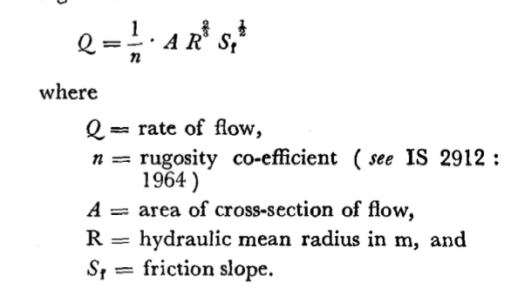

* + - * Q → obtain from Phase II
      * n → obtain from IS 2912: 1964
      * A → calculate from dimensions of valley
        + Depth of valley
        + Radius of valley?
        + Width of valley
      * R → Area of flow section/wetted perimeter
      * St →
    - *Afflux*: difference in water level at any point upstream of barrage before and after construction of dam
      * WIDTH of dam governed by afflux (@ crest level)
    - Discharge:
      * 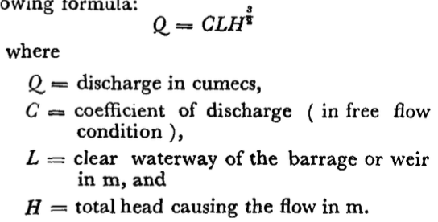

<https://www.usbr.gov/tsc/techreferences/mands/mands-pdfs/SmallDams.pdf>

**Small Dams**

* Ch 4 A Classification of Types: Concrete Gravity Dams (Pg 62)
  + Concrete Gravity Dam good for suitable rock conditions
  + Well suited for overflow spillway crests
  + Either straight or curved in plan
  + Stronger foundation → less excavation
* Ch 4 B Physical factors Governing Selection of Type (Pg 64)
  + Type of foundation (rock, gravel, silt/fine sand, clay) depends on geological conditions
  + Availability of materials = big contributor
  + Hydrological factors
  + Spillway
  + Earthquake conditions
* Ch 8 Concrete Gravity Dams (Pg 315)
  + Forces acting on Dam
    - external water pressure
    - Temperature
    - Internal water pressure
    - Weight of structure
    - Ice pressure
    - Silt pressure
    - Earthquake
    - Force from gates/appurtenant structures

<https://albertawater.com/lifecycle-of-a-dam-and-reservoir/dam-and-reservoir-design>

**Dams and Reservoir Design**

* Berms: man-made sediment barrier placed at the edge of a slope or a wall built adjacent to a ditch to guard against potential flooding, run-off and high water; made of compost because density slows down flow of water
* Gravity Dam should be used for this project

<https://www.slideshare.net/bibhabasumohanty/reservoir-13443272>

**Reservoir**

By: Bibhabasu Mohanty

* Use a distribution reservoir
* Analytical Method for Reservoir Capacity
  + Monthly inflow data
  + Decide if anything will be released downstream
  + Determine direct precipitation volume falling on reservoir per month
  + Evaporation losses occurring from the reservoir
    - “The panevaporation data are normally used for the estimation of evaporation losses during the month”
  + Find demand of reservoir per month
  + Determine adjusted inflow during different months
    - Adjusted inflow = stream inflow + precipitation - evaporation - downstream discharge
  + Storage capacity for each month
    - Storage required = adjusted inflow - demand
  + Total storage capacity = sum ^
* Yield: max amount of water supply during a specific time
  + Decide if we want to include this?? Look back at slides
* Reservoir Sedimentation
  + Provide dead storage to account for accumulation of deposits during the life of the dam
  + Add a lot of vegetation around the dam to filter out sediment
    - Or coffer dams, low level outlets
    - Stepped watershed

***Phase III Progress Report***

The dam being built for the EWB’s India project is an Anicut Dam. An *anicut structure* serves to retain a percolation pond. A *percolation pond* is a shallow artificial pond whose function is to allow stormwater to infiltrate through the permeable soil into a groundwater aquifer. Percolation ponds are advantageous in managing stormwater runoff, preventing flooding and downstream erosion, and improving water quality. The Indian Standard (IS 6966) has prescribed their own guidelines for designing percolation ponds. Enumerated is the following data that is required in order to properly size a percolation pond: cross section of the river, slope of river bed, soil samples, daily rainfall data, daily river stage, and aerial map of floodplain.

The dimensions of the basin need to be obtained in order to understand the size, and shape of the valley which will be utilized for the percolation pond. Some important dimensions are the slope of the valley, the distance between the two peaks, and the change in elevation along the line which the anicut will be built on. Figure 1 shows an elevation of the valley where the anicut structure will be built. The left peak is at an elevation of 1245’ and the right peak is at an elevation of 1236’. The lowest part of the valley is at 1227’. The slope of the valley was determined by iterating the elevation line over the valley at set intervals, and dividing the change in elevation over the change in distance. The iterated elevation lines can be seen in Figure 2.

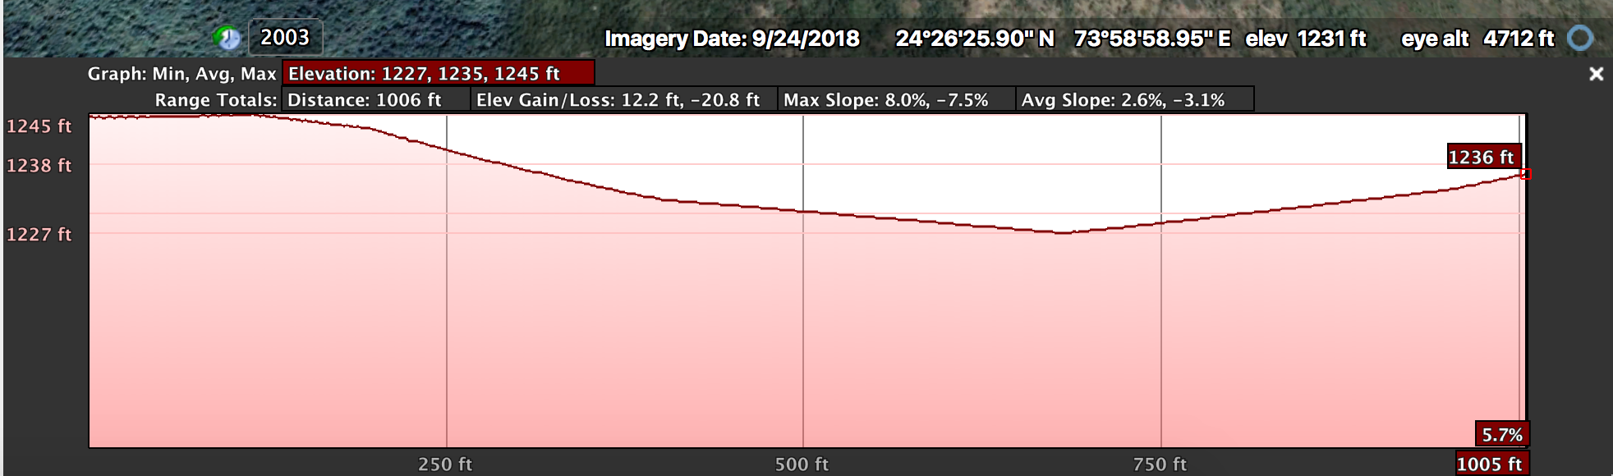

*Figure 1: Elevation of Valley*

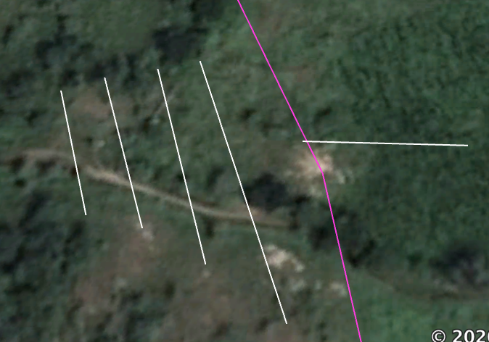

*Figure 2: iterated Lines to Find Slope of Valley*

With this preliminary data, as well as the volume of runoff from phase II, we will be able to utilize code in order to dimension the anicut structure. We will be able to determine the height at which the dam needs to be in order to retain the water, and through the height determine the length of the dam. With the length and height of the dam our team should be able to determine the full dimensions of the dam. Once the anicut structure has been designed, the area of the pond behind the dam can be fully designed, knowing both the maximum height at which the pond can rise, and the full width at which the pond can spread.

Phase III involves the use of equations, and functions in order to determine the dimensions of the percolation pond anicut system. The first task will be to find the maximum runoff within the given range of years. This maximum runoff will allow the team to develop a percolation pond that can handle the largest inflow of water. Using google Earth Pro a relationship between length of dam and Height of dam was determined, and a csv file was made called “Anicut Elevation.csv”. An If else statement was made where if a Dam height was inputted, the code would output the length of the dam.

Moving forward, as the code for Phase III must begin before the output of runoff from Phase II is delivered, the original precipitation data will be used as a temporary proxy for these runoff values. This csv file will be simplified into the same format as expected for the runoff values so that a simple substitution can occur once the real values are obtained. The expected reservoir capacity will be found by obtaining the maximum runoff during the wet season. This volume in part with the depth and width of the reservoir(height and length of the dam) will be used to calculate the desired length of the reservoir. A factor of safety shall be applied while obtaining the depth of the reservoir from the height of the anicut.